**Component Diagram**

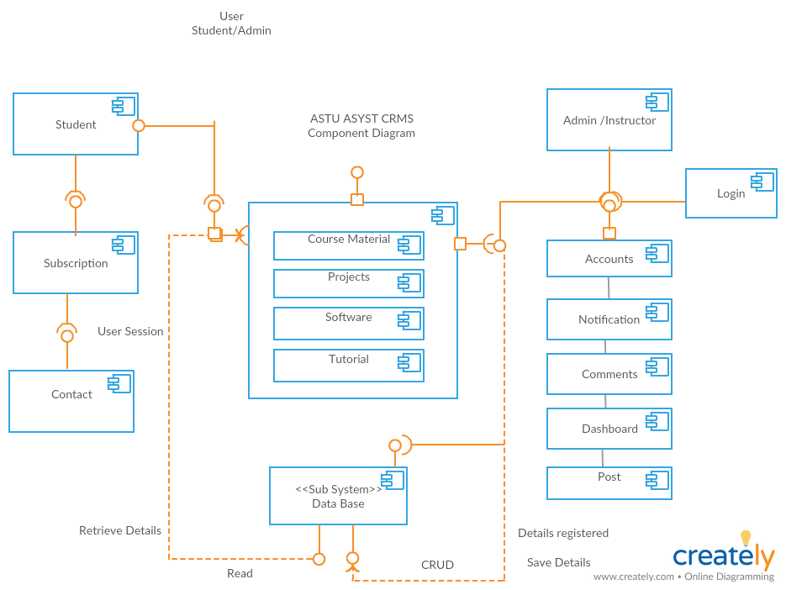

**Access Control and Security**

Due to the prototype demo nature of the CRMS project, the access control and security issue is addressed in a testing level with necessary hash and encryption methods at security points like login subsystem. A crypt function of cost 12 is used from PHP built in function with a 22 character random salt.

A secure access control mechanism that prevents unauthorized or even malicious users  
from using the network must be incorporated. The access control mechanisms must operate  
fully transparent to any correspondent node in the network. End users of the access network  
should, apart from the initial authentication at login time, not notice any changes when using  
the network (i.e., standard applications must be fully supported).  
Network security is a broad topic that can be addressed at the data link, or media level at the network, or protocol, layer (the point at which Internet Protocol (IP) packets and routing updates are controlled), and at the application layer (where, for example, host-level bugs become issues).

Due to the limitation of the current working environment, the IPv6 will not be used in this CRMS project, rather in the future version.

**Access Matrix**

